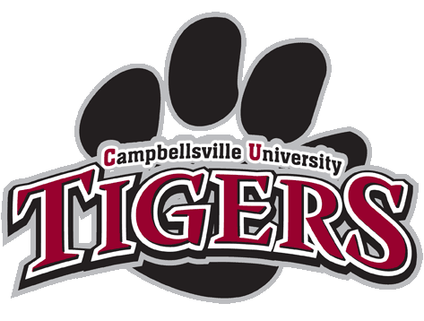

Intensive English Learning & American Culture
Immersion Program

4 Week Summer Program/ Session 1
June 30th – July 28th, 2017

4 Week Summer Program/ Session 2(required TOEFL ibt 80+)
July 14th – August 11th, 2017

Table of Contents
Welcome and Information……………………………………………………………………………….....……………………………..…………….2
Summary of Content for Classroom Courses……………………………………………………………………………………………………..3
Daily Schedule for Courses………………………………………………………………………………………….…………………………………….4
Schedule for Activities and Field Trips……….…………………………………………………….………………………………………………..6
List of Weekly Cultural Classes………………………………………………………………….…...………………………………………………...7
General Information……………………………………………………………………………………….……………………………………………...8
Destination Photos………………………………………………………………………………………………………………………………………….9
Welcome Intensive English Language Learning Session Students!

Campbellsville University is proud to offer a 4-week Summer Intensive English Learning and American Culture Immersion Program (I.E.L.P.) for international students. The program includes three classroom instruction courses and one course which includes at least three official field trips of American culture immersion. These courses count for a total of 12 non-credit hours of instruction:
- IEL101 – Grammar, within Writing
- IEL102 – Writing
- IEL103 - Reading & Conversation, Lab
- IEL104 - Student Activity Class, Including Field Trips
This course allows students to experience American culture and enhance microscope language skills.

This 4- week Summer Intensive English Learning and American Culture Immersion Program also offers the following:
- Sports Activities Internships - Includes Music and the Health & Physical Education Area of study.
Riding Horse back for beginners at Local Horse Farms. Golf, Tennis,…etc
- Teaching Activities Classes – Visit local, private elementary through high schools in Taylor County, Kentucky.
- Internship/Student Activity Class for Business, Social Work, and Nursing Programs - Includes visits to local nursing home and hospitals with Campbellsville University nursing students, and University courses in the School of Business and Social Work.

Through the scheduled activities, we are confident that each student’s experience will be rewarding and unforgettable!

Important Application Dates / Session 1

Application Begins:
Monday, May 1st, 2017

Application Deadline:
Friday, June 16th, 2017

To Access Application Information, Follow These Steps:

Go to www.campbellsville.edu

Under Academics, Select “International Education”

Under Future Students, Select “I.E.L.P. Program”/Intensive English Learning Program and American Culture Immersion for International Students

Summary of Content for Classroom Courses

The program content for each course is as follows:
- IEL101, English Grammar and Syntax: Content will include verbs, tense agreement, nouns and pronouns, idioms, prepositions, comparatives and superlatives, punctuation and capitalization, adjectives and adverbs, and common grammatical mistakes of IEL learners.

- IEL102, English Writing: Content will include proper sentence and paragraph structure, the writing process, writing instructions and directions, comparing/contrasting, writing opinions, summarizing reading materials, and writing essays.

- IEL103, English Conversation and Reading: Content will include learning effective listening and speaking skills and improving vocabulary and reading comprehension.

- IEL104, Student Activity Class: Field Trips and Cultural Activities will enhance learning about the customs and culture of America. This includes local short trips and a CU campus tour.

Each class will incorporate four, essential research-based activities for learning English: speaking (fluency and pronunciation), listening (oral comprehension), reading (vocabulary and comprehension); and writing. There will be daily homework assignments, and in-class activities will include individual and group work. Students will be required to practice on their own at the computer lab, and will be scheduled for individualized tutoring and English practice with master’s level instructors from the English as a Second Language Center for Excellence. Courses will be held in Campbellsville University’s Alumni Building.

www.campbellsville.edu click,
Academics-International Students click, New Students-I.E.L.P. Program click

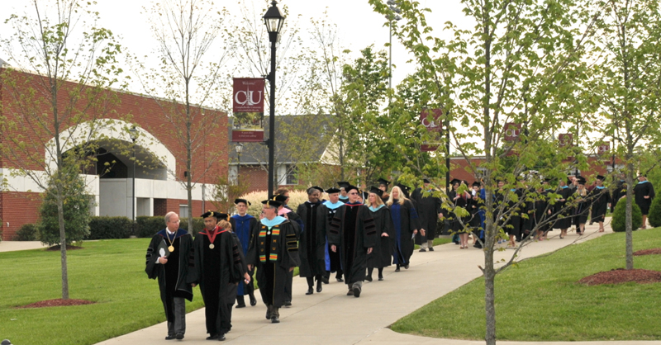
Session 1 - Detailed Daily Schedule for Courses

Orientation: Monday, July 3rd, 2017

10:00 a.m. – 11:00 a.m. Official Welcome and Orientation: Speaking by Dr. Michael V. Carter, President, and Dr. Kwang H. Suh, Program Director

10:30 a.m. – 12:00 p.m. Placement Testing
Go to CU registrar to receive student ID cards.

12:00 p.m. – 1:00 p.m. Lunch

1:00 p.m. Cultural and English conversation tour of the CU campus led by a member of the Campbellsville University student ambassadors.

3:00 p.m. Students depart for dorms.
Note: Classes will begin at 8:30 a.m. on Wednesday, July 5th.

Monday, Tuesday, Wednesday, & Thursday:

8:30 – 9:30 a.m. IEL 101-01 Grammar/Syntax & Writing
IEL 101-02 Grammar/Syntax & Writing
IEL 101-03 Grammar/Syntax & Writing

9:45- 11:00 a.m. IEL 102-01 Fundamentals of Writing & Reading
IEL 102-02 Fundamentals of Writing & Reading
IEL 102-03 Fundamentals of Writing & Reading

11:15- 12:30 a.m. IEL 103-01 Conversation/Lab
IEL 103-02 Conversation/Lab
12:30-1:30 p.m. Lunch in CU Cafeteria
2:00 – 4:30 p.m. IEL 104 Activity Class, and including field trip class

Friday:

6-8 hours Field Trip

*All students are required to be in the computer laboratory or library if not in class.
Instructors will provide students with detailed lesson plans for each class at the start of the session.

July Fourth of 2017 for 4 week Summer program at Campbellsville university / Detail schedules are TBA

Independence Day (United States)___________All Copy by internet Access
Independence Day of the United States, also referred to as the Fourth of July or July Fourth in the U.S., is a federal holiday commemorating the adoption of the Declaration of Independence 241 years ago in 1776 on July 4 by the Continental Congress. It declared that the thirteen American colonies regarded themselves as a new nation, the United States of America, and were no longer part of the British Empire.^{[1]}

Independence Day is commonly associated with fireworks, parades, barbecues, carnivals, fairs, picnics, concerts, baseball games, family reunions, and political speeches and ceremonies, in addition to various other public and private events celebrating the history, government, and traditions of the United States. Independence Day is the National Day of the United States

Background
During the American Revolution, the legal separation of the Thirteen Colonies from Great Britain in 1776 actually occurred on July 2, when the Second Continental Congress voted to approve a resolution of independence that had been proposed in June by Richard Henry Lee of Virginia declaring the United States independent from Great Britain rule.^{[5][6]} After voting for independence, Congress turned its attention to the Declaration of Independence, a statement explaining this decision, which had been prepared by a Committee of Five, with Thomas Jefferson as its principal author. Congress debated and revised the wording of the Declaration, finally approving it two days later on July 4. A day earlier, John Adams had written to his wife Abigail:
The second day of July, 1776, will be the most memorable epoch in the history of America. I am apt to believe that it will be celebrated by succeeding generations as the great anniversary festival. It ought to be commemorated as the day of deliverance, by solemn acts of devotion to God Almighty. It ought to be solemnized with pomp and parade, with shows, games, sports, guns, bells, bonfires, and illuminations, from one end of this continent to the other, from this time forward forever more.^{[7]}

July 4th Celebration | National Archives
https://www.archives.gov/calendar/july4
July 4th at the National Archives is made possible in part by the National Archives Foundation with the generous support of John Hancock and Dykema.

Images of july 4th celebrations
bing.com/images
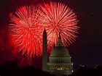
See more images of july 4th celebrations

Session 1 – Tentative Schedule for Activities and Field Trips
*Subject to Change

Friday, June 30th | O’Hare Airport Arrival – Chicago, IL  Students will be picked up at O’Hare airport and transported to a Hotel in Chicago loop, Chicago, Illinois.
Saturday, July 1st | Field Trip Class - Chicago, IL  University of Chicago, Northwestern University, and Chicago Loop
Sunday, July 2nd | Louisville Airport Arrival – Louisville, KY  Depart Chicago & Arrive at Louisville Airport; Students will be picked up and taken to CU campus dorm. No Charged airport pick up fee
Week 1
Tuesday, July 4th | Celebrate July 4th Iindependence Day
Saturday, July 8th | Field Trip Class – Louisville, KY  Churchill Downs  Lunch at KFC  CU Louisville and University of Louisville Campus Tour  Louisville Slugger Museum/ 세계적인 야구 방망이 공장
Sunday, July 9th | Field Trip Class - Louisville, KY  Culture Shock Class - Southeast Christian Church at Louisville, Kentucky  Shopping at Factory Outlet, Simpsonville, Kentucky  Depart Louisville at 4pm - Arrive CU Campus for Dinner at Cafeteria
Week 2
Friday, July 14th | Field Trip Class – Bardstown, KY (Lunch Provided)  Depart CU campus at 9:00 am
Saturday, July 15th | Field Trip Class - Depart CU campus at 9:00 am  Abraham Lincoln Birthplace: 9:30 am- 1230 pm (Lunch Provided  My Old Kentucky Home TBA  Mammoth Cave: 1:30 pm – 4 pm; Dinner at CU Dining Hall
Sunday, July 16th | Free Day
Week 3
Friday, July 21st | Music City of Nashville, Tennessee (Lunch Provided)  Depart CU campus at 9:00 a.m. – Arrive Nashville at 11:15 a.m.
Saturday, July 22nd | Music City of Nashville, Tennessee  Depart Nashville at 2:30 p.m. – Arrive CU campus for dinner at cafeteria
Sunday, July 23rd | Free Day
Week 4
Friday, July 28th | Graduation Ceremony at 11:00 A.M.  Shopping day for final at Louisville or Campbellsville – TBA

Session 1 – Tentative List of Weekly Cultural Classes
*Subject to Change
Week 1
Tuesday, July 4th | Celebration July 4th Independence Day
Wednesday, July 5th | Phillips Bowling Lanes / Green River Movie Theater
Thursday, July 6th | CU Swimming Pool
Week 2
Monday, July 10 | TBA/ Fiesta Mexico
Tuesday, July 11 | TBA/ Horse bags? Culture Shock
Wednesday, July 12 | TBA/ Atkinson-Griffin House/ Green River
Thursday, July 13 | TBA/ Horse bags? Hiestand House
Week 3
Monday, July 17 | TBA/ Police/Fire Stations
Tuesday, July 18 | TBA/ Horse bags? Clay Hill
Wednesday, July 19 | TBA/ KFC Original Store in Corbin, Kentucky
Thursday, July 20 | TBA/ Horse bags?
Week 4
Monday, July 24 | TBA/ Visit Grandview Nursing Home
Tuesday, July 25 | TBA/ Horse bags? Attends Local Festival
Wednesday, July 26 | TBA/ Paint Your Pottery
Thursday, July 27 | TBA/ Horse bags? Game Day

General Information

Emergency Contact:

Campus Security Gard /24 hrs. 270-789-5555 or 911
Mrs. Davis, Campus Nurse 270-789-5235
Dr. Suh, Director 270-789-5051
Coordinator included Teaching instructor TBA
Administrative Assistant TBA
Ms. Elise Mohon, Instructor 270-403-3508
Teaching Instructor TBA
Teaching Instructor TBA
Field Trip Instructor TBA
Driver TBA

Director Contact Information:

Dr. Suh
Phone: 270-789-5051 ext. Dr. Suh
Fax: 270-753-0276
E-mail: khsuh411@gmail.com or khsuh@campbellsville.edu
http:// www.campbellsville.edu

Please send all Admission documents to the address listed below:

Dr. Kwang Suh
Director of Asian Studies & Academic Advisor
1 University Drive, UPO 796
Campbellsville University
Campbellsville, Kentucky 42718
U.S.A.

Important Notice: All students are expected to bring a pillow, sheets and blankets for their beds. Students should also be sure to bring Bathing Suit, exercise shoes, and other clothes to utilize the Fitness Center on the Campbellsville University Campus, which is available for student use daily.

Destination Photos
Chicago, Campus of University of Chicago & Northwestern University in Chicago
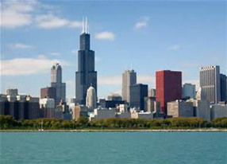 |  | 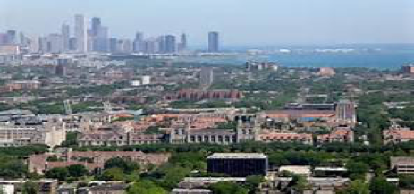 |  |  | 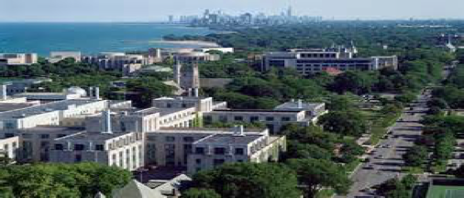
Field Trip to My Old Kentucky Home, Abraham Lincoln Birthplace & Mammoth Cave
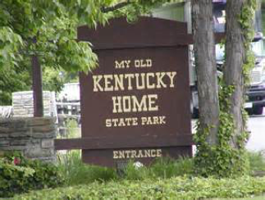 |  | 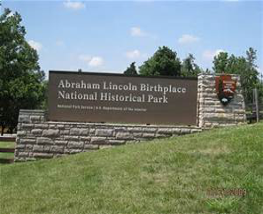 |  |  | 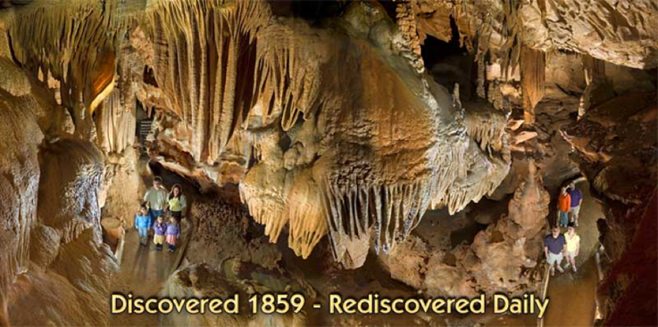
Churchill Downs, Louisville Slugger Bats Museum, Univerity of Louisville & Kentucky
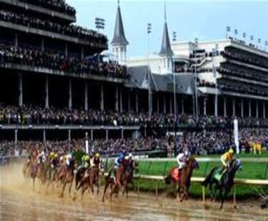 | 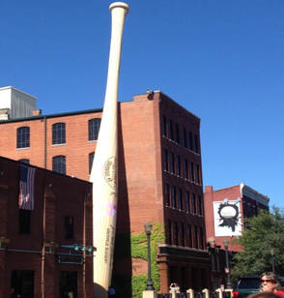 |  | 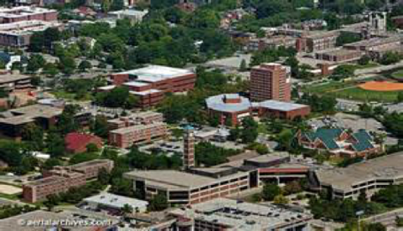 |  | 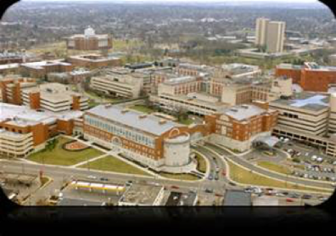
Field Trip to Original KFC Harland Sanders café and Museum in Corbin, Kentucky
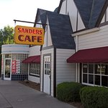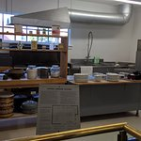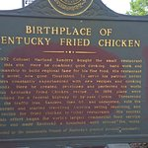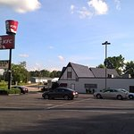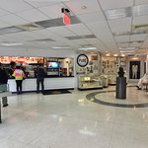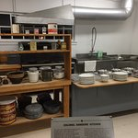

Music City of Nashville, Tennessee
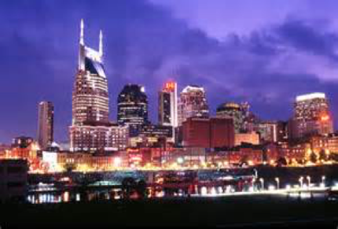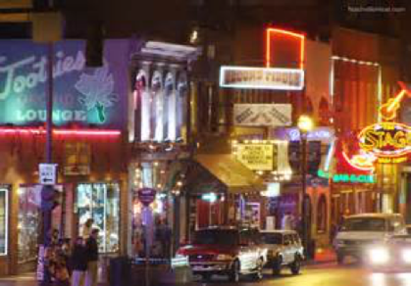  Music City of Nashville, Tennessee |  |  |  | Campbellsville, Kentucky  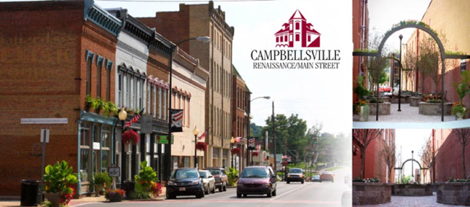
Intensive English Learning and American Culture Immersion Program (IELP)
4 Week Summer 2017 June 30th – July 28th and July 14th – August 11th ※基本費用
구 분/ Contents | 비 용/ Fees | 비 고/ Note
등록비/Registration fee | Application fee $100  Processing fee $150 | Non refundable
수업료/Program fee  (included Field trips) | $1,720 | Maximum 17  Students/ each class
학생활동비/Student Activity fee | $170  10名 未滿 $420
숙식비/ Room & Board fee | $1,260 included Dorm Key  (Room $700 + Board $560)
총계/Grand Total | $3,400 + $250/10名 以上  $3,650 + $250/ 10名 未滿 | Grand Total: $3,400  Grand Total: $3,650

구분 | 비용/Cost | 비고/Note
공항픽업비/  Free Airport transportation | 全額 無料and 1名 未滿 自擔  *Louisville Airport to Campbellsville Univ. Campus  78 Miles/ 125 Km | 단기 프로그램의  건강보험은 자담  Self - Health Insurance
교재비/ Books | $65-$105 自擔 | Text books
其他/others | Self-Response | No Health Insurance  required for short term
總 計/Total fees | $3,400.00  (Room & Board + Program fees) | End of due date:  Friday, June 16th, 2017

